Intergenerational
Holiday Gift Make and Take

Saturday, December 8th
10am-1pm
~ Fun Crafts for all ages ~
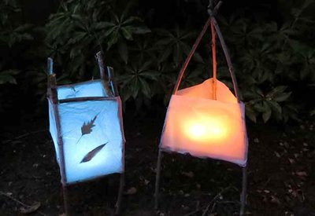
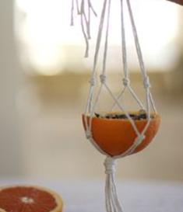
Bird Feeders, Hand-made Soap, Ornaments, Candle Lanterns, Wooden Boxes & More
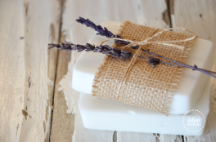

Quaker Meetinghouse
11 Oxbow Pond Rd, Canterbury NH
Pre-Registration Appreciated (not required)
Call Ruth Heath 724-4343
Donations Requested at the door ~All proceeds to benefit the
Kakamega AIDS Orphans Care Center in Kenya

