Queries for Greeters who represent the Meeting to newcomers
? Are you helping all to feel welcome and valued?
? Are you helping to establish a worshipful atmosphere before and during Meeting?
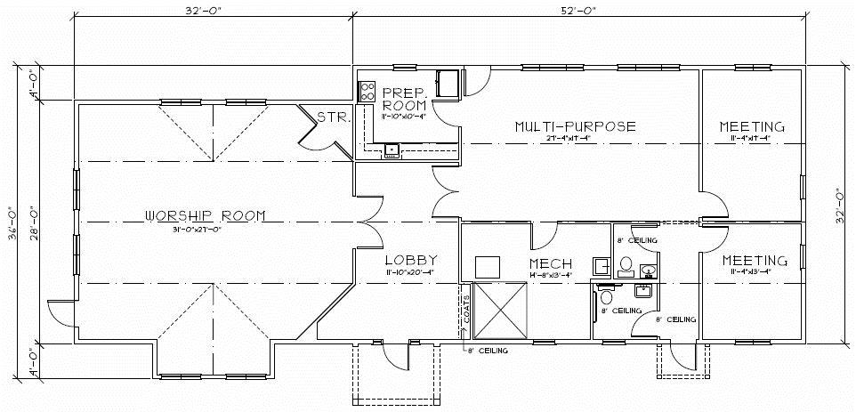
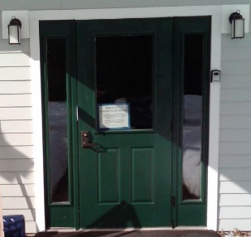 | On your arrival,  - Have you arrived 25-30 minutes before the start of singing at 10:00 am?  
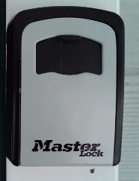 | At the Main Door,  - Is the front door unlocked (using your own key or the key in the Key Storage Box next to the main door of the Meetinghouse^{[1]})? [The combination is ______.]
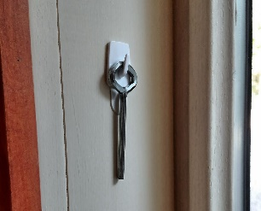 | - Is front door crash bar (‘panic bar’) on the inside of the door in the open position (‘dogged’) using the Allen key (aka, hex or ‘dogging’ key), which hangs on the right side of the door frame?
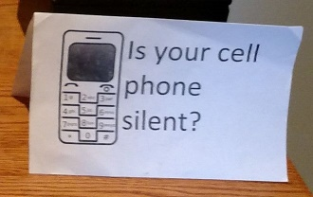 | In the Lobby,  - Is the “Is your cell phone silent?” sign on the greeting table and/or main table?
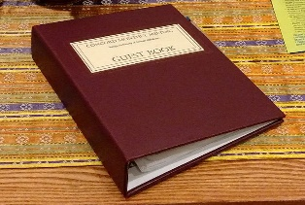 | - Is the Guest Book on the main table open to a page with blank spaces and a working pen nearby?
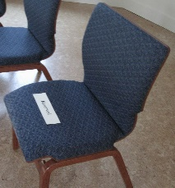 | In the Meeting Room,  - Have you put the “Reserved” card (kept in the Audio Closet in the Meeting Room) on a chair near the doors so that you can see latecomers arriving?
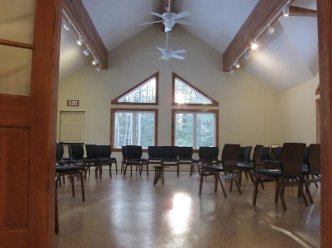 | - Are the ‘outward-facing’ spotlights on? (The panel is on the right side of the doorway as you enter the room.)  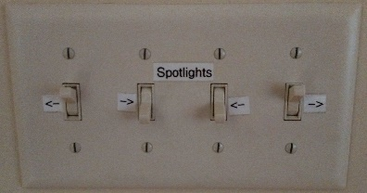
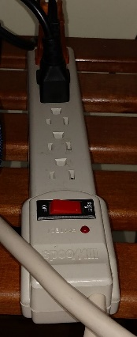 | In the ‘Audio Closet’ in the Meeting Room,  - Have you checked that the hearing system is set up and working? Turn on the power strip in the closet in the Meeting Room. All the switches & dials are preset.  - Have you turned on the wireless microphone and replaced the battery, if necessary?  - Have you checked the receiver headsets for proper operation and replaced batteries, if necessary?
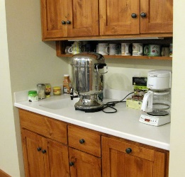 | In the Fellowship/Multipurpose Room,  - Is there time to set up tea water and coffee? Is the hot water pot turned on?
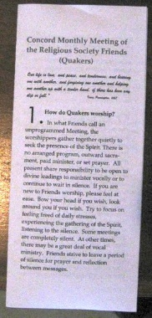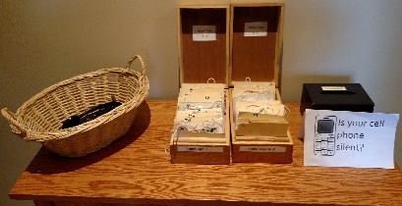 | As people arrive,  - Are they newcomers? If so, have you asked them if they have attended a Quaker Meeting before? If they haven’t, have you offered them ‘Facts About Quakers [1]’? (Have you spent whatever time they may need, speaking softly in the lobby, on what to expect or questions they may have?) Have you offered them a Name Tag? (Blank tags and pens are in the drawer of the ‘greeting table’ in the lobby.)  - Have you asked if they need a hearing assistance headset (in the basket) to increase ‘hearability’ of spoken messages?
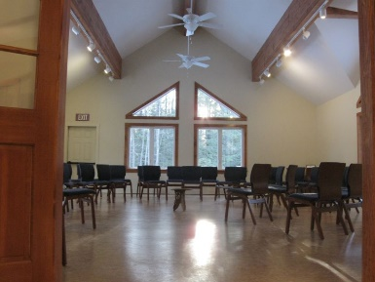 | When singing begins,  - Have you closed the double doors to the Meeting Room and the Fellowship Room?  When singing ends,  - Have you propped open the Fellowship Room and Meeting Room doors?  When most or all singers have left the Fellowship Room and entered the Meeting Room,  - Have you closed the Fellowship Room and Meeting Room doors?
 | - If people are still conversing, have you politely asked for quiet?
 | As latecomers (including those still coming over from singing) arrive and for 10-15 minutes after the start of Meeting,  - Are you grouping latecomers for entry at the same time?  - Are you quietly opening and closing the Meeting Room doors?
 | At 10-15 minutes after the start of Meeting,  - Have you returned to the seat ‘Reserved’ for the Greeter?  - Are there latecomers who are first-time Attenders at Meeting? If so, have you stepped into the lobby with the newcomer to provide whatever orientation they may need?
 | After Meeting, Introductions, and Announcements,  - During Announcements, have you turned on the coffee pot and hot water for tea?  - Have you welcomed any newcomers once again? Have you asked them if the Meeting for Worship was what they expected? Have you answered any questions they may have had? Have you invited them to sign the Guest Book? Have you invited them to fill in a ‘Welcome Card’?  - Have Friends been invited to share tea, coffee, and cookies?

[1] Here’s a link to a video that shows how it works. User Guide Video: http://bcove.me/jqdsi9ks [3]
Concord Monthly Meeting of the Religious Society of Friends (Quakers)
11 Oxbow Pond Road,
Canterbury, New Hampshire 03224-2043 USA
Links:
[1] https://www.concordfriendsmeeting.org/FactsAboutQuakers
[2] https://www.concordfriendsmeeting.org/sites/all/files/documents/GuidanceForGreeters,v.1.0a.pdf
[3] http://bcove.me/jqdsi9ks
Dear Greeters,
The Outreach Committee has created a “welcome card” that we hope greeters will give to first time attenders or second time attenders. This does NOT replace signing the guest book, but is (hopefully) another way to help newcomers feel welcome. We ask you give it to them AFTER worship when you approach them to talk with them. You probably already asked them to sign the Guest Book when they arrived. This is a chance for them to react and ask for more information, once they have experienced worship with us.
The cards are in the front cover of the Guest Book, and also in the plastic stands near the name tags. They are a quarter sheet size (little larger than a postcard); here is the text:
You are Welcome Here!
Please check any activities that are of interest:
o Coffee and Conversation with a Quaker
o Meal at a member’s home
o Receive email announcements weekly
Or put questions or comments on other side. Someone will get back to you soon!
Your name: ________________________________
Your phone: _______________________________
Your email: ________________________________
(Explain that their email into the Guest Book will also get them on the weekly email list.)
WHEN TO GIVE THE CARD: We thought that some people might not want to use the card after their first visit, but by the next visit, we should definitely ask them if they’d like to sign it in order to get more connected with us.
WHAT TO DO WITH FILLED OUT CARD: We didn’t discuss what to do with the cards.... If they say receive email, Greg should get a copy of it (could be a picture emailed or texted to him). Someone on Outreach will need to get back to them within a day or two if they check either coffee or a meal option. Giving it to Mark, Sara, Heidi, or Ruth (whoever is there that day) would be best. Or taking a picture and texting or emailing to all of us would be best if none of us is there (unlikely).

