Lois Pitkin Booth

1922-2019
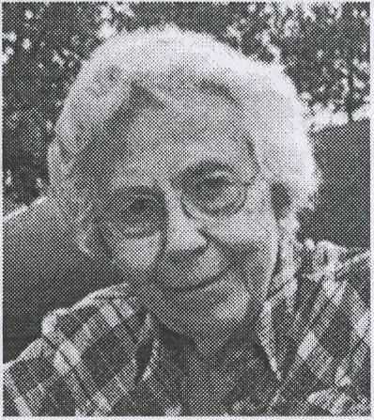

Memorial Service
2pm Nov 9, 2019
Unitarian Universalist Church, Concord NH
Welcoming comments (Steve Booth)
Song: Simple Gifts
Barbara Booth Berwick comments
The Garden Song
Song for Lois (Jon & David Booth)
Arnie Alpert comments
Song: Finlandia
Quaker silent worship (Ruth Heath)
Please wait for the microphone to speak
Song: Dona Nobis Pacem

Simple Gifts
’Tis the gift to be simple, ’Tis the gift to be free
’Tis the gift to come down where we ought to be
And when we find ourselves in the place just right
It will be in the valley of love and delight
When true simplicity is gained
To bow and to bend, we will not be ashamed
To turn, turn, will be our delight
’Til by turning, turning, we come ’round right

Song For Lois (by Jon Booth)
She said Mother we have found a new community
There will be four other families where we stay
She said I think that we can lead the life we want to lead
And I believe we'll find our way
She said I know you really want that school that's far away
But the money is impossible to spare
She said I think that we should take a look there anyway
And we just might get you there
She said long hair shouldn't mean to keep him out of school
To be true to one’s perception is okay
She said it is our best protection from a tyrant's rule
And we can let them choose their way
She said meeting time for kids can be a place to learn
That every child should feel loved every day
We’ll sing songs of hope together that will long endure
And they will help you on your way
She said imagine looking down upon this world at war Through the eyes of one who gave the life we share
She said are you not weeping for the mourning here
And I hope we'll find our way
I hope we'll find our way

Garden Song (Inch by Inch)
CHORUS:
Inch by inch, row by row; Gonna make this garden grow
All it takes is a rake and a hoe; And a piece of fertile ground
Inch by inch, row by row; Someone bless these seeds I sow
Someone warm them from below; Till the rain comes tumbling down
Pulling weeds, picking stones; We are made of dreams and bones
Need a place to call my own; For the time is near at hand
Grain for grain, sun and rain; Find my way in nature's chain
Tune my body and my brain; To the music from the land
(REPEAT CHORUS)

Finlandia (Song of Peace)
This is my song, O God of all the nations
A song of peace, for lands afar & mine
This is my home, the country where my heart is
Here are my hopes, my dreams, my holy shrine
But other hearts in other lands are beating
With hopes and dreams as true and high as mine
My country’s skies are bluer than the ocean
And sunlight beams on clover leaf and pine
But other lands have sunlight too, and clover
And skies are everywhere as blue as mine
O hear my song, thou God of all the nations
A song of peace for their land and for mine

In lieu of flowers, donations are invited to either:
NH Peace Action
https://nhpeaceaction.org/donate/
American Friends Service Committee – NH
https://www.afsc.org/office/concord-nh
Both organizations share the same office:
4 Park St., Suite 304
Concord, NH 03301
For photos and stories of Lois, or to leave
comments or remembrances, visit:
https://loisbooth.wordpress.com

